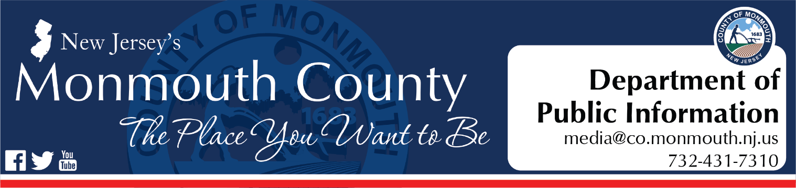
For Immediate Release:
November 22, 2022

County finalizes Belford Ferry service contract; Seastreak to begin providing services on Dec. 5

FREEHOLD, NJ – The Monmouth County Board of County Commissioners has announced that a contract has been finalized with Seastreak to begin offering ferry services between the Belford Ferry Terminal and Manhattan starting Dec. 5.

“The new contract between the County and Seastreak will provide significantly more options to residents traveling to and from New York City,” said Commissioner Director Thomas A. Arnone. “Seastreak will have vessels dedicated to the Belford Ferry Terminal, offering six morning departures from Belford to Manhattan and seven evening departures directly from Manhattan to Belford. These new routes will be in addition to those already offered by Seastreak between Highlands, Atlantic Highlands and Manhattan, with all terminals utilizing the same tickets.”

Under the new agreement, the Seastreak’s terminals in Highlands and Atlantic Highlands will be connected to the Belford Ferry Terminal via a free SeaStreak shuttle bus service.

“Commuters leaving Manhattan will have a total of 22 departure options per day and the flexibility to return to their vehicles from any of the terminals located in Monmouth County,” said Commissioner Director Arnone. “As the need for ferry services has increased, the County wanted to make sure that travelers had a multitude of safe, reliable options to travel between Manhattan and Monmouth County, especially during peak travel times.”

Seastreak plans to expand its seasonal excursions to include departures from the Belford Terminal, and Monmouth County residents will be able to take advantage of seasonal weekend ferry services starting in Spring 2023.

“Our team looks forward to working with Monmouth County to serve the County’s residents and provide the Belford commuter community with the same high level of service and commitment that the Company has provided to its riders for over three decades,” said Seastreak Vice President of Operations John J. Bevins. “We are committed to providing safe and reliable transportation in the years to come and thank our riders for their continued support.”

“Monmouth County is committed to a smooth transition between our previous partner, New York Waterways, and Seastreak to guarantee travelers will not be impacted by the change in service providers,” said Commissioner Director Arnone.

More information about Seastreak may be found at www.Seastreak.com.

